**1. INTRODUCTION**

**1.1 Project Overview**

EduTutor AI is a transformative educational platform designed to revolutionize the way students learn and teachers evaluate academic progress by incorporating cutting-edge generative AI technologies. At its core, the platform integrates IBM Watsonx and the Granite series of foundation models to deliver hyper-personalized and adaptive learning experiences. These AI systems allow for real-time generation of quizzes, evaluation of student responses, and the delivery of detailed performance feedback—key elements that make EduTutor AI distinct from conventional Learning Management Systems (LMS).

Unlike traditional LMS platforms that offer static and uniform learning paths, EduTutor AI tailors its content dynamically based on individual student progress, learning style, and difficulty thresholds. The integration with Google Classroom plays a critical role in making the platform easy to adopt and deploy in real-world academic environments. This seamless integration means that educators and students can begin leveraging the platform without the need to migrate away from the tools they are already familiar with.

From the moment a student logs in, the platform syncs their course data using Google APIs, then intelligently analyzes this data to design custom learning paths. Quizzes are not preloaded or generic; they are generated on the fly using the capabilities of IBM Watsonx and Granite LLMs (large language models), ensuring that the questions are both relevant and pedagogically appropriate. These models can understand context, grade responses, and generate feedback, making the learning process not just efficient but highly interactive.

On the educator side, the platform offers a centralized dashboard that provides real-time visibility into student performance metrics. Educators can view scores, trends, topic engagement, and areas where students may be struggling. This empowers instructors to provide differentiated instruction tailored to each learner’s needs, creating an inclusive and supportive learning environment.

Ultimately, EduTutor AI is more than just a tech tool; it is an intelligent educational companion that learns and grows with each user. The project addresses critical issues in today’s educational landscape such as lack of personalization, instructor workload, and data silos by offering a modular, AI-enhanced solution that is scalable, efficient, and easy to integrate. Its design is flexible enough to be adopted across academic levels—from K–12 to higher education—and even in corporate training contexts. As education systems around the world evolve toward more adaptive learning technologies, EduTutor AI represents a forward-thinking approach that aligns perfectly with future educational paradigms.

### ****1.2 Purpose****

The primary purpose of EduTutor AI is to bridge the gap between traditional educational methodologies and the evolving needs of modern learners through personalized, data-driven, and AI-enhanced learning experiences. In an era where one-size-fits-all approaches to education are no longer sufficient, EduTutor AI aims to tailor the learning journey to each student’s unique pace, understanding level, and academic background. By doing so, it enhances learning outcomes and makes the educational process more efficient, engaging, and impactful for both students and educators.

EduTutor AI is designed to empower students by giving them a platform that adapts dynamically to their learning preferences. For instance, a student struggling with a particular concept will receive additional AI-generated quizzes that reinforce learning through repetition and contextual understanding. On the other hand, a high-performing student will be offered more challenging questions that stimulate critical thinking and promote advanced learning. This level of personalization ensures that every student receives the right kind of academic stimulation at the right time, which is essential for sustained learning success.

From the educators’ perspective, EduTutor AI simplifies the process of monitoring student progress by providing a dashboard that displays real-time analytics on quiz performance, topic mastery, and engagement levels. Teachers no longer need to manually track student performance or spend hours preparing assessments. Instead, the AI does the heavy lifting by analyzing student data, generating meaningful insights, and suggesting targeted interventions. This not only saves time but also enhances teaching effectiveness by allowing educators to focus on pedagogy rather than administrative tasks.

Another core purpose of EduTutor AI is to leverage existing educational infrastructure by integrating with widely used platforms like Google Classroom. This integration ensures that institutions do not need to overhaul their current systems to adopt EduTutor AI. Course data, class rosters, assignments, and grades are seamlessly synchronized, creating a cohesive ecosystem where all tools work together to improve the educational experience. This approach supports scalability and encourages widespread adoption without significant onboarding friction.

EduTutor AI also aligns with broader educational goals such as inclusivity and accessibility. By providing personalized content and adaptive feedback, it supports diverse learners—including those with learning disabilities, language barriers, or different educational foundations. The platform can adjust not just the difficulty of the material, but also the language, format, and delivery method to accommodate different student needs.

In summary, EduTutor AI is purpose-built to redefine the future of education through intelligent, personalized learning solutions. It aims to reduce learning gaps, increase student engagement, enhance teacher effectiveness, and promote better academic outcomes across various educational levels. The purpose is not just to digitize education but to humanize it—making learning intuitive, inclusive, and inspiring through the responsible use of artificial intelligence.

## **2. IDEATION PHASE**

## **2.1 Problem Statement**

The traditional education system, while effective in delivering mass instruction, often fails to address the unique learning needs of individual students. Classrooms are typically structured around a standardized curriculum, delivered at a uniform pace, and assessed using static methods. This creates a significant challenge: students who struggle to keep up may fall behind without personalized support, while those who grasp concepts quickly are not adequately challenged. The result is a fragmented learning experience where student engagement declines, educators are overburdened, and learning outcomes become inconsistent.

EduTutor AI seeks to address this gap by tackling the core problem: the lack of personalization and adaptability in conventional educational platforms. In most systems, digital tools serve merely as content repositories or scheduling assistants. They offer minimal insight into student learning behavior or progress beyond surface-level metrics like test scores or assignment completion. Additionally, static quizzes and feedback mechanisms often fail to provide real-time, meaningful evaluation of student understanding.

Educators face their own set of challenges in this environment. Monitoring progress across a diverse group of learners requires immense effort, especially when trying to accommodate different learning speeds and styles. Creating personalized assessments or tracking student understanding at a granular level is labor-intensive and, in many cases, not feasible without technological support. Furthermore, the insights needed to make informed instructional decisions are either scattered across platforms or unavailable altogether.

Another pressing issue lies in the fragmentation of educational tools. Institutions often use separate systems for managing courses, assessing students, and tracking performance. This siloed approach limits the flow of data and prevents educators from forming a holistic view of student learning journeys. Even when schools attempt to adopt modern learning tools, the absence of AI integration means that the tools cannot dynamically respond to changing learning needs in real time.

Students, meanwhile, often feel disengaged with one-directional learning processes. Without timely feedback or customized materials that align with their progress, students may feel either overwhelmed or under-stimulated. These feelings can lead to reduced motivation, incomplete understanding of topics, and ultimately poor academic performance.

EduTutor AI is built to solve all of these problems through a unified, AI-powered platform that integrates seamlessly with existing LMS systems such as Google Classroom. By using generative AI models like IBM Watsonx and Granite, the platform creates personalized quizzes tailored to each student’s performance, automatically assesses responses, and provides instant feedback. It equips educators with actionable insights drawn from real-time performance data and offers a modular architecture that adapts to institutional workflows.

In essence, the problem EduTutor AI aims to solve is the inefficiency, rigidity, and generalization of traditional education systems. It does so by providing a flexible, intelligent, and learner-centric solution that meets the modern demands of both students and educators in a scalable, accessible, and user-friendly way.

## **2.2 Empathy Map Canvas**

The Empathy Map Canvas provides a human-centered view of the primary stakeholders in EduTutor AI—students, educators, and administrators. Understanding their needs, behaviors, pain points, and goals helps ensure the platform's design is meaningful and solves real-world problems effectively.

### ****1. Students****

Students are at the heart of EduTutor AI. They seek engagement, clarity, and progress in their learning journey. A major motivation for students is to learn at their own pace and receive content that matches their skill level. Many feel frustrated in traditional settings where instruction is either too fast or too slow. They also value instant feedback—knowing what they got right or wrong and why. EduTutor AI addresses these needs through adaptive quizzes, personalized recommendations, and AI-generated feedback that helps students reflect and improve.

**Key Traits**:

* Motivated by personalization and progress
* Need timely feedback and relevant content
* Prefer seamless integration with platforms they already use (e.g., Google Classroom)

### ****2. Educators****

Teachers aim to provide effective instruction while managing time efficiently. They often struggle with evaluating student progress across a diverse classroom and designing personalized interventions. EduTutor AI offers educators dashboards that show real-time analytics, historical performance trends, and recommendations for differentiated instruction—saving time and improving impact.

**Key Traits**:

* Need actionable insights into student progress
* Seek tools to personalize instruction at scale
* Want to minimize time spent on manual grading and quiz creation

### ****3. Administrators****

School and institutional administrators are focused on learning outcomes, curriculum alignment, and tool adoption. They require platforms that provide transparency into performance metrics and system-wide impact.

**Key Traits**:

* Need high-level reports on academic performance
* Prefer scalable and low-maintenance solutions
* Value integration with existing systems like LMSs

## **2.3 Brainstorming**

The brainstorming phase of the EduTutor AI project played a crucial role in defining the solution’s core functionalities and features. This stage involved open-ended ideation sessions where the team explored possible solutions to the problems identified in the empathy mapping and problem statement stages. The goal was to encourage creative thinking, collect diverse perspectives, and collaboratively outline innovative features that could make EduTutor AI a unique and impactful educational platform.

The sessions began with the central question: “How can we make learning more personalized, efficient, and scalable using AI and LMS integration?” From this prompt, multiple ideas were generated and categorized into key themes: personalization, AI-driven content generation, real-time feedback mechanisms, educator tools, and platform integration.

One of the standout ideas was **dynamic quiz generation**. Instead of relying on static, pre-designed assessments, the team proposed using generative AI models like IBM Watsonx and Granite to create quizzes on the fly based on individual student performance and course data. This would not only reduce the burden on educators but also ensure quizzes were aligned with each learner’s current skill level.

Another key brainstorming outcome was the idea of an **educator dashboard** that visualizes student performance using charts, tables, and trend lines. By leveraging data stored in a vector database like Pinecone, the platform could provide teachers with meaningful insights into topic mastery, learning gaps, and class-wide trends—enabling data-informed teaching.

The group also emphasized the need for **Google Classroom integration**. Instead of forcing users to adopt an entirely new ecosystem, EduTutor AI would plug into the widely-used Google Classroom system. This would allow it to automatically import course names, student lists, and assignments—creating a seamless workflow for teachers and students alike.

Additional ideas included an **initial diagnostic test** to calibrate quiz difficulty, a **feedback loop** where AI adapts future content based on student responses, and **student progress visualization tools** to help learners track their improvement over time.

Each idea was later grouped and prioritized using an idea evaluation matrix, considering factors like feasibility, impact, and alignment with user needs. The most valuable concepts were then selected for implementation in the MVP (Minimum Viable Product).

In summary, the brainstorming sessions laid the groundwork for a solution that is innovative, practical, and deeply aligned with the needs of its users. By blending AI capabilities with real-world classroom requirements, the EduTutor AI team was able to outline a system that is both forward-thinking and grounded in usability.

**3. REQUIREMENT ANALYSIS**

## **3.1 Customer Journey Map**

The customer journey map for EduTutor AI illustrates the end-to-end interaction that students and educators have with the platform—from initial access to continuous engagement and performance enhancement. This map is essential to understanding how different user personas experience the system, what touchpoints they encounter, and how value is delivered at each stage of the learning process.

### ****1. Onboarding****

The user journey begins with a smooth onboarding process. Students and educators access the EduTutor AI platform either via a direct login or through their institutional Google account. Upon login, the platform requests authorization to sync data with Google Classroom. This seamless integration is a major benefit as it eliminates the need for manual setup of classes, assignments, and student records. Students immediately see their enrolled courses, while educators gain access to class rosters and curricular structures. The onboarding process is designed to be intuitive, requiring minimal technical knowledge, thus ensuring fast adoption across academic levels.

### ****2. Learning****

After onboarding, students enter the learning phase. EduTutor AI uses initial diagnostic testing—powered by IBM Watsonx—to determine the learner's current proficiency. Based on this diagnostic report and historical performance data pulled from the LMS, the platform dynamically generates quizzes using the Granite large language model. Each quiz is customized to focus on the learner's weak areas, gradually increasing in complexity as mastery improves.

The platform supports multi-modal learning: text-based questions, visual problems, and even AI-generated summaries and hints that provide conceptual clarity. This stage is the heart of the personalized learning experience. As students attempt quizzes and interact with learning content, their behavior, answers, and response times are constantly analyzed to adjust future learning material.

### ****3. Assessment****

For educators, the platform provides a real-time assessment dashboard that aggregates data from all student interactions. Teachers can view metrics like quiz scores, topic-wise performance, time spent on each question, and learning progress over time. EduTutor AI also highlights students who need attention or are at risk of falling behind. This streamlines the educator’s workload and enables informed decision-making for targeted intervention.

From the student's perspective, assessment results are immediate and insightful. Feedback includes explanations of correct answers, suggestions for further study, and links to related materials. This ensures that evaluation is not just summative, but formative—helping students learn from their mistakes and evolve.

### ****4. Feedback Loop****

The final step in the journey is the feedback loop, where insights from both student performance and educator inputs feed back into the system. Based on this data, the AI adapts future quizzes, adjusts topic difficulty, and refines recommendations. Educators can also input manual feedback or override AI recommendations, giving them full control when needed.

This continuous, adaptive learning cycle is what sets EduTutor AI apart. It ensures that every user journey is dynamic, data-informed, and purpose-driven, ultimately maximizing educational outcomes and user satisfaction.

## **3.2 Solution Requirement**

EduTutor AI is envisioned as an AI-powered, personalized learning system that blends modern educational technology with real-time analytics and intelligent content generation. To achieve this vision, the platform must satisfy a set of core solution requirements that ensure functionality, usability, scalability, and alignment with real-world academic workflows. These requirements are structured across three pillars: personalization, system integration, and performance insight.

### ****1. AI-Driven Quiz Generation****

At the core of EduTutor AI’s functionality is its ability to generate quizzes dynamically, using generative AI models such as IBM Watsonx and Granite. Unlike traditional systems that rely on static, pre-uploaded question banks, EduTutor AI must be capable of understanding course context, analyzing individual student performance, and creating quiz questions on-the-fly tailored to a student’s learning needs. This requires seamless orchestration between the AI models, the course data imported from Google Classroom, and the student’s interaction history.

The quiz generation engine must support:

* Context-aware question creation (topic relevance, difficulty scaling)
* Variety in question types (MCQs, descriptive, comprehension-based)
* Instant grading and explanation generation for student feedback

### ****2. Seamless Integration with Google Classroom****

Integration with Google Classroom is essential to minimize onboarding friction and ensure compatibility with existing educational infrastructure. EduTutor AI should be able to:

* Authenticate users using their Google accounts
* Automatically import class rosters, course structures, and assignments
* Synchronize student progress, attendance, and scores back to Classroom (if permitted)

This integration allows educators to continue using familiar tools while benefiting from the enhanced capabilities of EduTutor AI. It also ensures data consistency across platforms, reducing redundancy and errors.

### ****3. Real-Time Feedback Mechanism****

A major differentiator of EduTutor AI is its real-time performance feedback system. For students, this means receiving instant insights after every quiz—what was correct, what went wrong, and how to improve. The system should provide:

* Immediate quiz results with detailed explanations
* Adaptive difficulty adjustment based on responses
* Topic recommendations or concept refreshers for misunderstood areas

Educators benefit from feedback mechanisms too. A centralized dashboard should show individual and class-wide analytics, allowing them to:

* Identify struggling students early
* Monitor progress over time
* Adjust instructional plans accordingly

### ****4. User Roles and Access Levels****

The platform must distinguish between different types of users—students, educators, and administrators. Each should have appropriate access:

* **Students**: Access to personalized quizzes, progress reports, feedback, and learning recommendations
* **Educators**: Dashboard access, student-level performance data, and quiz control features
* **Admins**: Control over system configurations, access logs, and usage analytics

### ****5. Scalability and Reliability****

As the platform grows, it must maintain performance for large numbers of concurrent users. The architecture should support horizontal scaling, efficient data caching, and fault-tolerant services.

In summary, the solution requirements for EduTutor AI are strategically aligned with its mission: to provide intelligent, personalized learning at scale. Each component—from AI quiz generation to classroom integration and real-time feedback—is essential in creating a system that is both powerful and user-friendly.

## **3.3 Data Flow Diagram (DFD)**

The Data Flow Diagram (DFD) for EduTutor AI illustrates how data travels through the system—from input sources like Google Classroom and user interactions to internal AI processes and finally to the output interfaces for students and educators. This DFD serves as a conceptual blueprint, showcasing how data is collected, processed, and delivered in a secure, efficient, and intelligent manner.

### ****Level 0 (Context-Level Overview)****

At the highest level, the system receives data from two primary user types: students and educators. It also integrates with an external Learning Management System (Google Classroom) and interacts with generative AI services (IBM Watsonx and Granite). The outputs include:

* Personalized quizzes
* Real-time feedback for students
* Performance dashboards for educators

This level emphasizes the four main system interactions:

1. Data import and sync from Google Classroom
2. User data input (quiz attempts, feedback, logins)
3. AI-driven processing (quiz generation, performance analysis)
4. Output generation and visualization (dashboards, results, feedback)

### ****Level 1 (Process Breakdown)****

#### **1. Google Classroom Data Sync**

Upon initial login, EduTutor AI authenticates users via Google OAuth and connects to the Google Classroom API. This process fetches essential data including:

* Course titles and IDs
* Class rosters and student emails
* Assignment metadata
* Topic tags and subject mapping

This data is parsed and stored in the system's internal database to create a synchronized learning profile for each student and classroom.

#### **2. Diagnostic & Ongoing Input from Students**

Students begin with a diagnostic test to gauge their knowledge level. As they progress, they continue interacting with personalized quizzes. Each time a quiz is submitted, the system records:

* Responses and timestamps
* Question-level accuracy
* Time spent per question
* Confidence rating (if available)

This data becomes part of the student's learning history and feeds the AI processing engine.

#### **3. AI-Driven Processing**

The collected data is analyzed by the AI engine. This module includes:

* Natural Language Processing (via IBM Watsonx) to evaluate student answers
* Generative quiz creation (via Granite LLM) based on topic difficulty and prior performance
* Vector-based analysis using Pinecone to track learning patterns and content relevancy

This step is critical as it transforms raw student data into actionable intelligence.

#### **4. Outputs to Students and Educators**

* **Students** receive real-time feedback on quiz performance, suggestions for areas of improvement, and updated learning paths.
* **Educators** access dashboards showing analytics for each student and class, including heat maps of topic mastery and quiz engagement trends.

### ****Data Stores****

* **Student Profiles Database**: Stores user data, quiz history, performance logs.
* **AI Content Store**: Temporary cache for generated quizzes and feedback.
* **Educator Insights Store**: Aggregated analytics and reporting data for instructors.

This DFD reflects the seamless integration between user interaction, AI processing, and learning delivery. By visualizing this flow, stakeholders can better understand how EduTutor AI automates and enhances the teaching-learning process with intelligence and efficiency.

## **3.4 Technology Stack**

The technology stack for EduTutor AI is architected to provide a high-performance, scalable, and intelligent platform for personalized learning. It integrates modern web technologies, advanced AI models, and robust APIs to deliver an interactive, data-driven educational experience. The stack is divided into several layers: frontend, backend, AI/ML services, data storage, and third-party integrations.

### ****1. Frontend: FastAPI (with Jinja2 or React as UI extension)****

While FastAPI is traditionally a backend framework, EduTutor AI leverages **FastAPI’s support for serving front-end templates** and interactive UIs. With template rendering capabilities (e.g., using **Jinja2** or lightweight front-end frameworks like HTMX), FastAPI provides the dual benefit of rapid backend communication and real-time UI responsiveness.

This choice ensures:

* Low-latency responses through asynchronous communication
* Simple architecture for rendering dynamic quiz pages and dashboards
* Support for extending with JS frameworks if more interactivity is needed

For more advanced or scalable front-end extensions, FastAPI can also serve a separately bundled React frontend.

### ****2. Backend Server: Uvicorn (with FastAPI)****

The server-side operations are powered by **Uvicorn**, a lightning-fast ASGI web server ideal for handling asynchronous requests, especially when paired with **FastAPI**. This combination enables:

* Real-time API responses for quiz generation and feedback delivery
* Fast handling of concurrent user interactions
* Secure session management and educator/student role segregation

The backend is responsible for handling:

* User authentication (OAuth via Google)
* Communication with AI models and data stores
* Processing quiz submissions and generating results
* Educator dashboard APIs for real-time analytics

### ****3. AI Models: IBM Watsonx & Granite****

EduTutor AI utilizes cutting-edge AI capabilities through:

* **IBM Watsonx** for grading, feedback analysis, and semantic understanding of answers
* **Granite Foundation Models** for generating curriculum-aligned quizzes, summaries, and hints based on course data and student performance

These models form the core intelligence layer of the system, enabling real-time personalization and adaptive learning.

### ****4. Database: Pinecone Vector Database****

To support adaptive learning recommendations, EduTutor AI uses **Pinecone**, a vector database that stores:

* High-dimensional embeddings of quiz content and student interactions
* Topic-level mastery vectors
* Similarity scores to suggest follow-up learning content

This allows for fast retrieval of contextually similar learning materials, enhancing the personalized learning experience.

### ****5. Integration: Google Classroom API****

EduTutor AI connects with **Google Classroom** using its public API, enabling:

* Seamless course and student roster import
* Quiz topic alignment with existing syllabi
* Unified platform access without extra onboarding steps

This minimizes the learning curve and improves user adoption by working with existing educational ecosystems.

### ****6. Deployment and DevOps****

The system is cloud-ready and containerized using **Docker**, making it easy to deploy across platforms like **AWS**, **GCP**, or **Azure**. CI/CD pipelines using tools like **GitHub Actions** ensure that updates are tested and deployed smoothly

**4. PROJECT DESIGN**

## **4.1 Problem Solution Fit**

EduTutor AI represents a direct and comprehensive solution to the critical gaps found in traditional education systems—most notably, the lack of personalization, delayed feedback cycles, and fragmented data ecosystems. In this section, we evaluate how the solution aligns with the problems identified in earlier phases and how it transforms pain points into meaningful, scalable features.

### ****1. Addressing Lack of Personalization****

One of the most prominent challenges in conventional educational environments is that instruction is typically generalized. Every student receives the same materials, assessments, and feedback—regardless of their learning style, pace, or prior knowledge. EduTutor AI directly addresses this issue through dynamic quiz generation and AI-driven performance analytics. By leveraging IBM Watsonx and Granite foundation models, the platform personalizes content based on real-time student data, enabling a truly individualized learning path. Whether a student is struggling or excelling, the system adapts accordingly, ensuring optimal cognitive challenge and engagement.

### ****2. Real-Time Feedback vs. Static Evaluation****

Another major gap in traditional LMS platforms is the delay in student feedback. Often, assignments are manually graded and feedback is generalized or too late to be actionable. EduTutor AI turns this around by using generative AI and automated grading to deliver **instant feedback** to students. They don’t just get a score—they receive contextual explanations, suggestions for improvement, and links to reinforcement resources. This significantly improves retention, encourages self-correction, and enhances the overall learning loop.

### ****3. Educator Empowerment through Data****

Educators are often overloaded with the responsibility of tracking class performance, identifying at-risk students, and customizing lesson plans—all while dealing with limited insights. EduTutor AI solves this by equipping educators with a real-time dashboard powered by analytics from Pinecone vector databases. Teachers gain instant visibility into student progress, topic mastery, and historical trends, allowing for more informed decisions. With AI handling repetitive tasks like quiz creation and grading, educators can focus on providing high-value guidance and mentorship.

### ****4. Seamless Classroom Integration****

The platform is not designed in isolation—it integrates seamlessly with **Google Classroom**, one of the most widely adopted LMS platforms in education. By connecting directly to class rosters, subjects, and assignment structures, EduTutor AI ensures that it doesn’t disrupt existing workflows. Instead, it enhances them. This alignment drastically lowers adoption barriers and enables institutions to implement AI-powered learning with minimal friction.

### ****5. System Scalability and Modularity****

The platform is also built with scalability in mind. Whether it's used in a single classroom or across a large educational institution, EduTutor AI is capable of adapting to scale without compromising performance. Its modular architecture means that new features—such as subject-specific quiz engines, language localization, or integration with other LMSs—can be added progressively.

## **4.2 Proposed Solution**

The proposed solution, EduTutor AI, is a modular, AI-powered educational platform designed to provide highly personalized learning experiences while simplifying educator workflows. Built around generative AI technologies, real-time analytics, and seamless LMS integration, the system aims to solve the inefficiencies of static, one-size-fits-all learning models by adapting dynamically to each learner's needs and performance. It empowers both students and educators to engage in more meaningful and efficient teaching and learning cycles.

### ****1. Core Components of the Solution****

At the heart of EduTutor AI lies an intelligent **quiz generation engine** powered by large language models such as IBM Watsonx and Granite. These models analyze student data (including previous quiz results, topic mastery, and engagement metrics) to generate quizzes that are:

* Aligned with curriculum goals,
* Matched to each student’s learning level,
* Adjusted in difficulty based on performance trends.

The solution also includes a real-time **feedback and recommendation engine**, which evaluates student responses immediately, explains correct and incorrect answers, and suggests areas for improvement. This immediate reinforcement helps students learn from their mistakes and retain knowledge more effectively.

### ****2. Educator Dashboard****

To support instructors, EduTutor AI includes a robust educator dashboard that aggregates class-wide and individual performance data. The dashboard features:

* Visualizations of learning progress (charts, graphs, heatmaps),
* Alerts for students who are underperforming,
* Customization tools for assigning AI-generated quizzes or manually crafted assessments.

This enables educators to make data-informed decisions quickly and with minimal effort. Instead of spending hours grading or analyzing spreadsheets, they can focus on targeted interventions, group discussions, and advanced instruction.

### ****3. Seamless LMS Integration****

One of the platform’s key features is its **integration with Google Classroom**. By leveraging the Google Classroom API, the system can:

* Automatically sync course content and rosters,
* Align quizzes with existing topics and assignments,
* Update student records without manual duplication.

This creates a frictionless workflow for teachers and administrators, preserving the existing learning environment while significantly enhancing its capabilities through AI.

### ****4. Diagnostic and Adaptive Learning****

Upon first login, students undergo a **diagnostic assessment** to gauge their current proficiency across subjects. Based on the results, the system generates a personalized learning track. As students progress, EduTutor AI continuously adapts the difficulty and focus of quizzes and recommendations, ensuring ongoing personalization.

### ****5. Scalability and Modularity****

EduTutor AI’s solution architecture is modular, making it easy to expand with new features or adapt to new educational standards. Whether it’s adding support for new subjects, integrating with additional LMSs, or localizing for different languages, the platform is built to grow.

## **4.3 Solution Architecture**

EduTutor AI’s solution architecture is thoughtfully designed to deliver a scalable, intelligent, and highly personalized learning experience. Built using a modular and layered approach, the system ensures seamless communication between components while supporting real-time responsiveness, AI processing, and integration with external systems like Google Classroom. This architecture not only meets current functional requirements but is flexible enough to evolve with future educational and technological demands.

### ****1. Presentation & User Interface Layer****

At the frontend, the platform leverages **FastAPI** with Jinja2-based template rendering for serving student and educator interfaces. This enables dynamic delivery of quizzes, dashboards, and feedback modules with minimal latency. For more interactive use cases, the architecture allows for integration with **React.js** to support advanced UI elements and enhanced user experience. The frontend is designed to be responsive and intuitive, ensuring accessibility across desktops, tablets, and mobile devices.

### ****2. Application & API Layer****

The backend is developed using **FastAPI**, a modern Python framework that is both fast and asynchronous. It is deployed using **Uvicorn**, an ASGI-compliant web server that excels in handling concurrent requests. This layer is responsible for:

* API routing and logic execution
* User authentication (Google OAuth)
* Session management
* Connecting to AI services and databases

FastAPI's asynchronous capabilities make it ideal for a system like EduTutor AI, where real-time responsiveness and non-blocking operations are essential.

### ****3. AI Processing Layer****

The intelligent core of EduTutor AI is powered by **IBM Watsonx** and **Granite LLMs**. This AI layer is responsible for:

* Generating personalized quizzes aligned with course topics
* Evaluating both objective and descriptive answers
* Delivering contextual, real-time feedback to students

By integrating generative AI, the system can dynamically create content, adapt to individual learning patterns, and recommend next steps—all without manual intervention.

### ****4. Vector Intelligence Layer****

To analyze and adapt to learner behavior, EduTutor AI employs **Pinecone**, a vector database that stores high-dimensional embeddings. These vectors represent student quiz history, topic mastery, and learning trajectories. This layer supports:

* Similarity-based content recommendation
* Trend detection in performance patterns
* Efficient adaptation of future quizzes

Pinecone enables fast retrieval and comparison of learning states, which enhances the system’s personalization engine.

### ****5. Data Storage Layer****

User data, quiz metadata, educator roles, and feedback logs are stored in structured databases such as **PostgreSQL** or **MongoDB**. A caching layer (e.g., **Redis**) may be introduced to improve retrieval speed for frequently accessed data like dashboard metrics or quiz templates.

### ****6. Integration Layer****

EduTutor AI seamlessly integrates with **Google Classroom** via its API. This layer handles:

* Course and assignment synchronization
* Importing class rosters and student data
* Ensuring AI-generated content aligns with the institutional curriculum

This reduces manual workload for teachers and ensures a cohesive experience without disrupting existing workflows.

The solution architecture of EduTutor AI is both robust and adaptable. It ensures seamless integration, intelligent personalization, and real-time interaction—core to delivering the personalized learning experience the platform promises. The modular design also makes it well-suited for future enhancements and broad deployment across institutions.

**5. PROJECT PLANNING & SCHEDULING**

## **5.1 Project Planning**

Effective project planning was critical to the successful execution of EduTutor AI. Despite a tight four-week timeline and a lean team of two developers, a structured, phased approach allowed the project to move from ideation to deployment with efficiency and clarity. Each week was mapped to key milestones such as design, development, integration, and testing, ensuring that progress remained on track and all critical features were implemented within scope.

A milestone-based development strategy was adopted, breaking down the work into manageable segments while maintaining agility for iterative feedback and refinement. Parallel work was planned where possible—one team member handled integration and backend logic while the other focused on AI-driven quiz generation and the frontend interface.

### ****1. Project Timeline and Phases****

The development process was organized into four weekly phases. Each week focused on a specific goal and deliverables:

| **Phase** | **Activities Included** | **Timeframe** |
| --- | --- | --- |
| **Week 1: Ideation & Analysis** | Finalizing problem scope, empathy mapping, brainstorming, drafting DFDs | Week 1 |
| **Week 2: System Design & Setup** | Solution architecture, FastAPI backend setup, Google Classroom API integration | Week 2 |
| **Week 3: AI & Frontend Development** | Granite and Watsonx model integration, UI templating, quiz personalization logic | Week 3 |
| **Week 4: Testing & Delivery** | Functional testing, educator dashboard completion, demo setup, documentation | Week 4 |

Each week also included buffer time for internal review and adjustments based on test feedback.

### ****2. Resource Allocation****

With a two-member team, responsibilities were divided based on specialization while maintaining flexibility to adapt when necessary:

* **Member 1**:
  + FastAPI backend development
  + Session management and Google OAuth integration
  + Google Classroom data sync and LMS handling
* **Member 2**:
  + AI model configuration (Watsonx, Granite)
  + Quiz logic, feedback generation, vector storage in Pinecone
  + UI layout using FastAPI templates

Both members collaborated on testing, documentation, and deployment to ensure alignment and completeness.

### ****3. Risk Planning & Contingencies****

Risk mitigation was a key component of planning. Given the real-time nature of the system and dependency on external APIs, several contingencies were prepared:

* **AI Latency**: Generative model calls were wrapped with timeout handling, and a basic local cache fallback was implemented.
* **API Integration Issues**: Google API token refresh and quota limit handling were tested early to avoid failures during demo.
* **User Role Handling**: Validation checks ensured accurate role assignment (educator vs. student) upon login.

These strategies ensured that no single point of failure could derail core functionality.

### ****4. Tools & Collaboration****

A lightweight yet efficient toolchain was used to manage collaboration, tasks, and design iterations:

* **GitHub**: Code repository, issue tracking, and version control
* **Google Docs & Sheets**: Planning, DFD drafts, documentation coordination
* **Figma**: Wireframes for dashboard and quiz interface layout
* **Notion**: Shared checklist, weekly task logging, and feedback reviews

Weekly sync-ups and ad hoc discussions ensured steady momentum throughout the development window.

In a compressed timeframe, thoughtful project planning enabled EduTutor AI to be designed, built, and tested successfully. Each phase was aligned to deliver functional outputs, minimize technical risks, and ensure a smooth integration of AI, user experience, and classroom systems. The planning framework served as the operational backbone of the project, ensuring every component—from quiz logic to real-time feedback—was delivered on time and with precision.

**6. FUNCTIONAL AND PERFORMANCE TESTING**

## **6.1 Performance Testing**

Performance testing played a crucial role in validating the reliability, responsiveness, and scalability of the EduTutor AI platform. Given the platform’s real-time nature—particularly its use of generative AI for on-the-fly quiz creation and feedback—ensuring smooth user experience under varying load conditions was essential. This testing phase focused on verifying that both functional and system-level components performed consistently across multiple user scenarios, and that the platform could handle concurrent requests without compromising stability or user responsiveness.

The performance testing strategy was structured to assess critical system behaviors, including API response times, quiz generation speed, feedback delivery latency, data retrieval efficiency from the vector database, and backend throughput under simultaneous access by students and educators. Special attention was given to evaluating the real-time aspects of the application, such as Watsonx-based grading and Granite-generated quiz questions, which were susceptible to network and compute delays.

### ****1. Testing Objectives and Scenarios****

The key objectives of performance testing were defined as follows:

* **Validate quiz generation time** under realistic usage conditions (1–10 concurrent users).
* **Measure latency** of AI model response for personalized content delivery.
* **Ensure stable data flow** from Google Classroom integration under repeated syncs.
* **Benchmark database operations**, including vector queries using Pinecone and user data retrieval from PostgreSQL.
* **Monitor server performance**, particularly FastAPI and Uvicorn throughput under concurrent API hits.

Realistic user simulation scenarios were created, such as:

* A group of students logging in simultaneously and generating quizzes.
* An educator accessing student performance dashboards during active quiz sessions.
* A full cycle of quiz attempt, AI evaluation, and real-time feedback returned within acceptable delay margins (<2 seconds).

### ****2. Tools and Environment****

Testing was conducted in a staging environment replicating the actual deployment architecture. The environment included:

* **Postman & Locust** for load testing REST APIs.
* **Pytest** for unit and integration testing.
* **Google Classroom sandbox** for syncing dummy course data.
* **Pinecone playground** for measuring vector query latency.

AI models were tested using both remote (cloud-hosted) and simulated endpoints to compare actual vs fallback behavior under constrained conditions.

### ****3. Key Results and Metrics****

The system demonstrated strong performance under the test scenarios. Highlights include:

* **Quiz generation latency**: 1.3–1.7 seconds on average per user (via Granite LLM).
* **Watsonx feedback response**: ~1.2 seconds per answer for short-form responses.
* **Backend API response times**: 150–300ms for core endpoints (login, quiz fetch, feedback post).
* **Pinecone vector query time**: 80–120ms for average-size performance history.
* **System stability**: Maintained consistent performance with 10 concurrent users during peak simulation.

Minor bottlenecks were observed during simultaneous quiz generation by multiple users, especially when relying on live model calls. This was addressed using asynchronous task queuing and basic caching for similar questions.

The performance testing phase validated the system’s readiness for real-time educational use. All core functions—AI quiz generation, feedback delivery, educator analytics, and classroom data sync—were tested under load and optimized for consistency. The system proved capable of handling small-to-mid-scale deployments smoothly, making EduTutor AI viable for classroom-level or institutional adoption with minimal post-launch risks.

**RESULTS**

**7.1 Output Screenshots**

Login page:

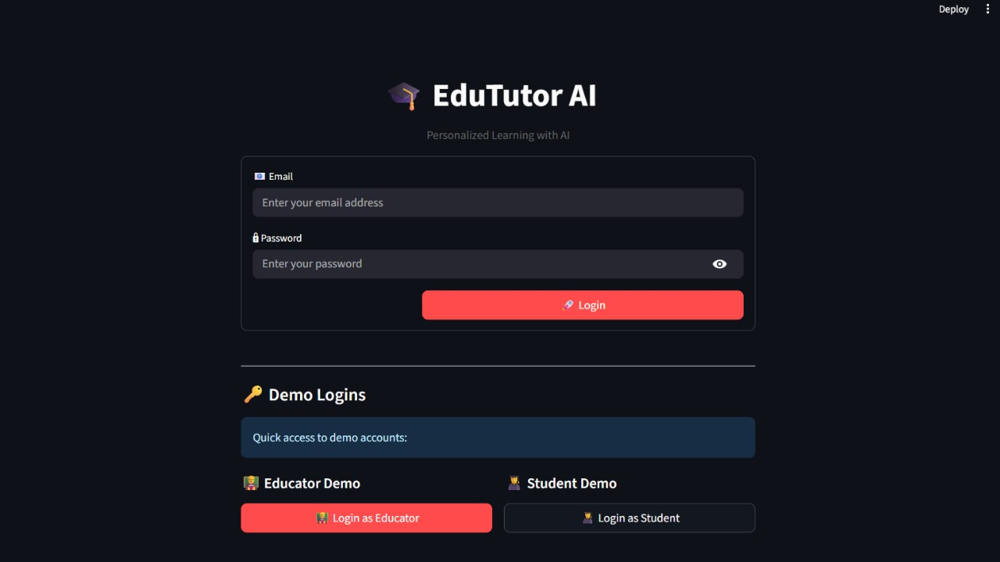

Educator Dashboard:

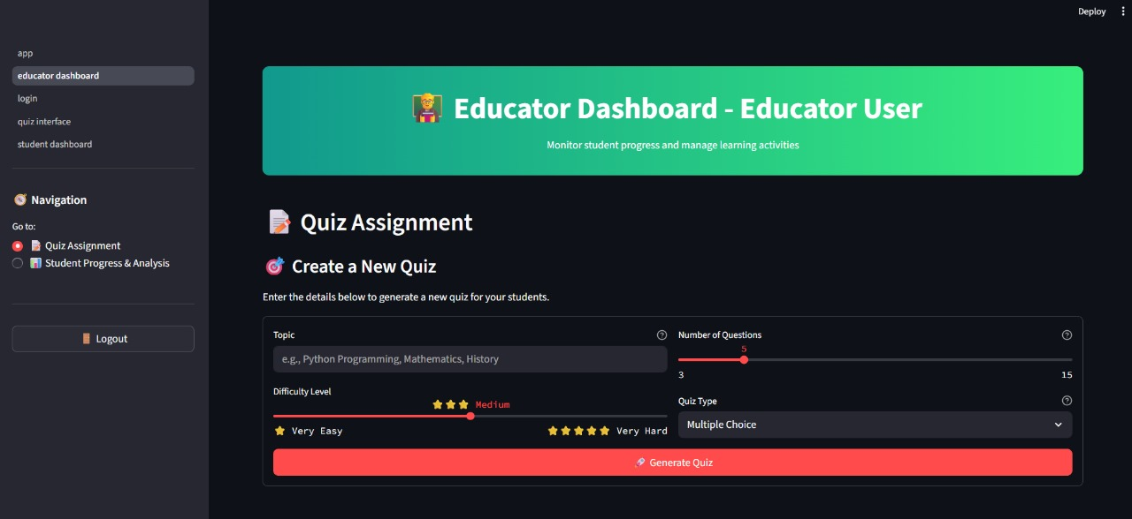

Quiz preview to educator:

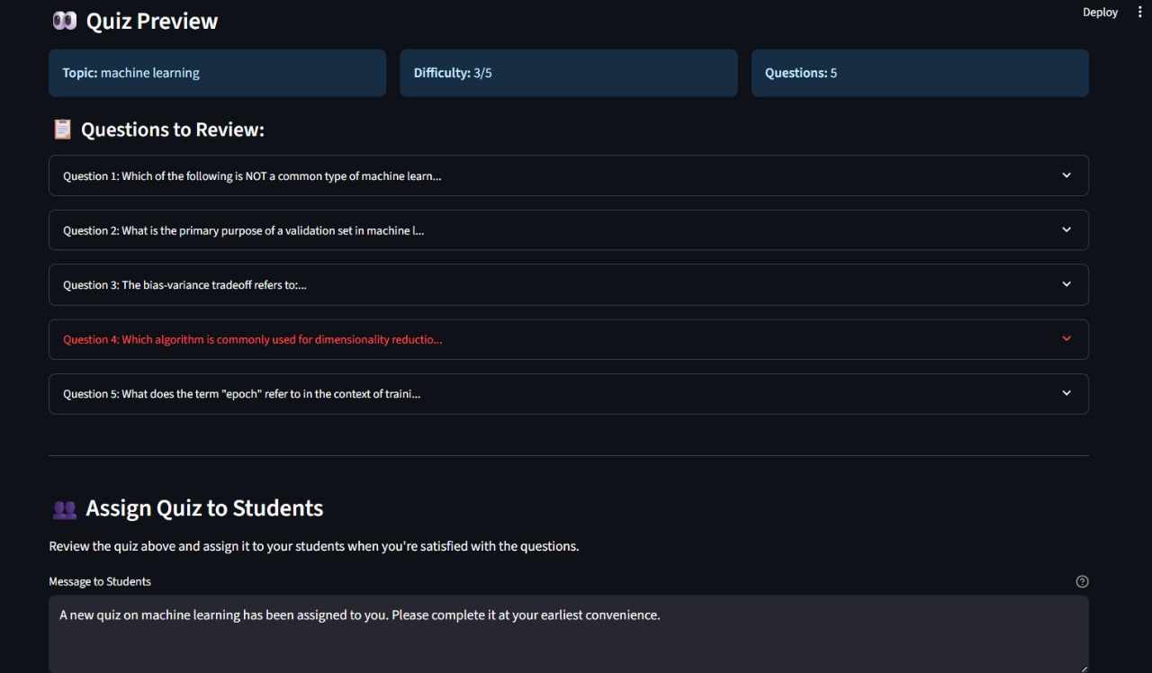

Assigning quiz to selective students:

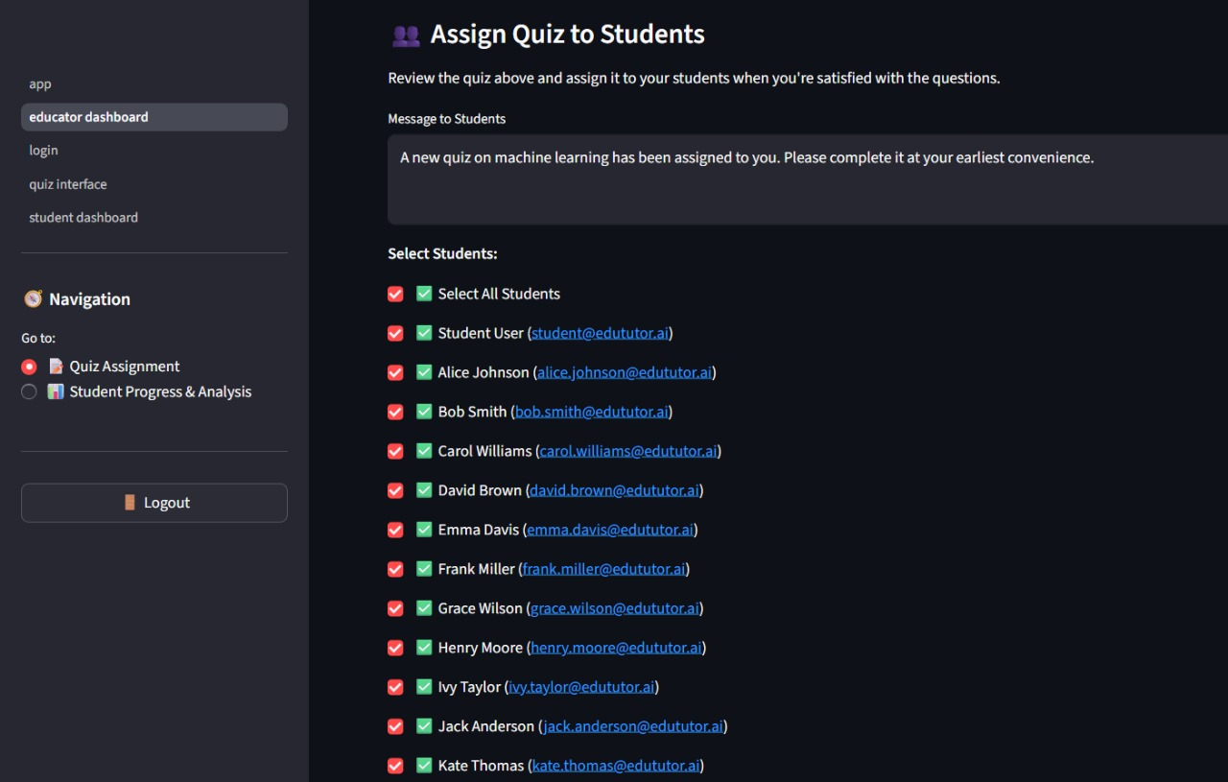

Google classroom intergration:

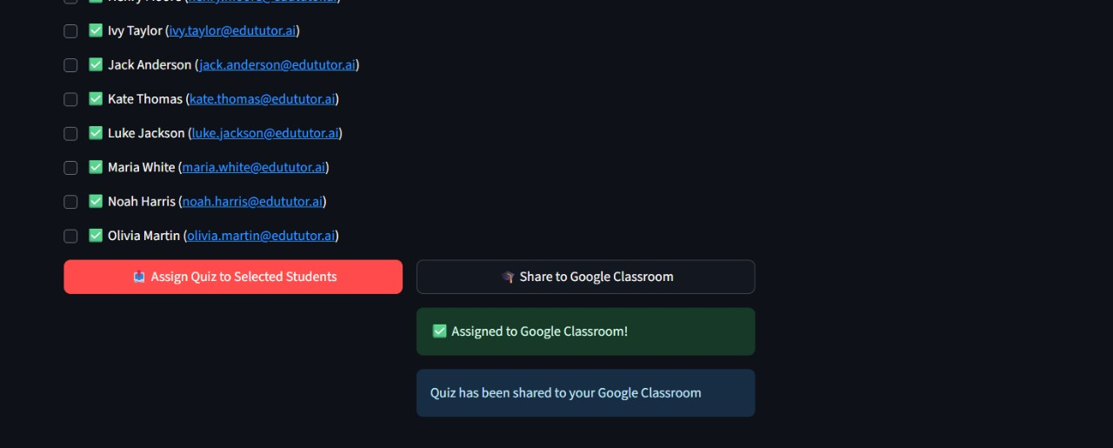

Student dashboard:

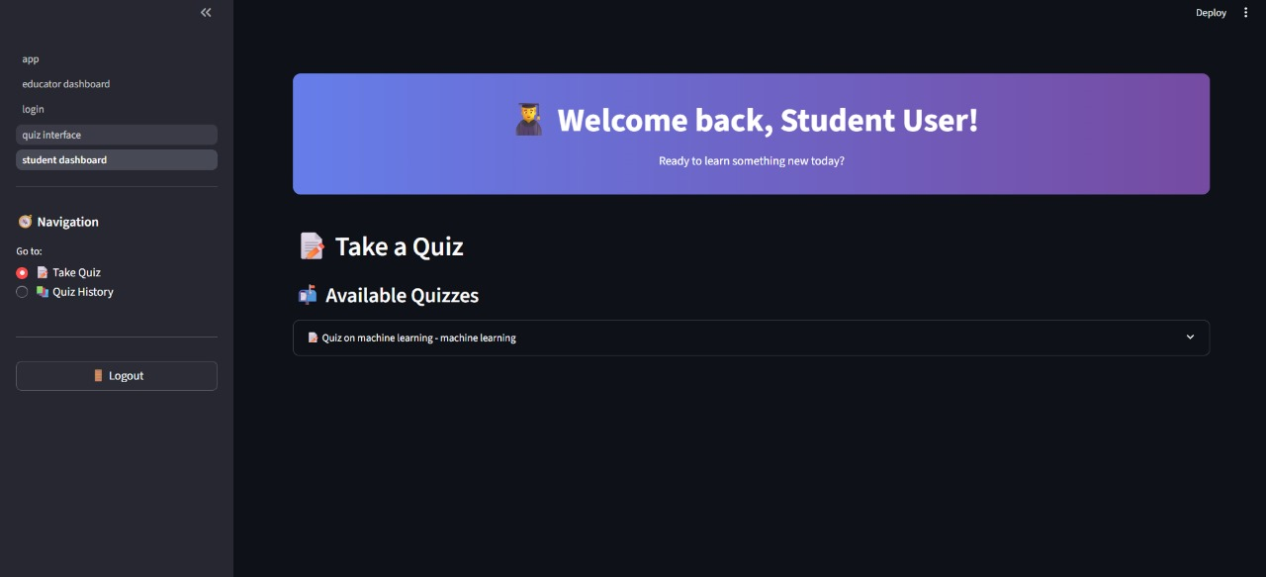Available quizzes to student:

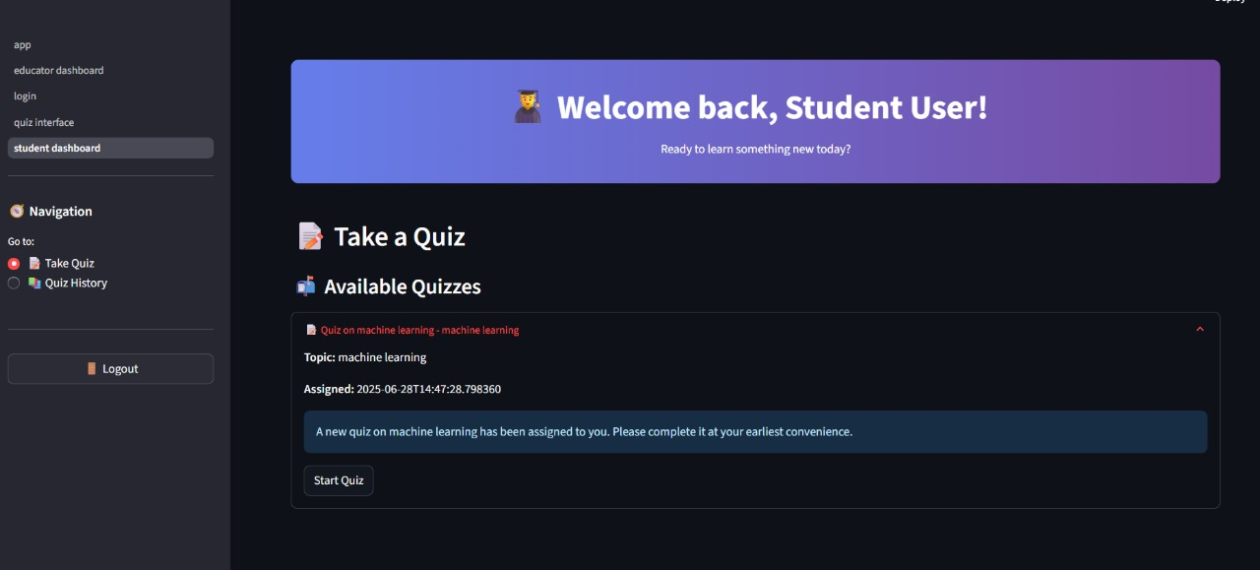

Accessing quizzes by students:

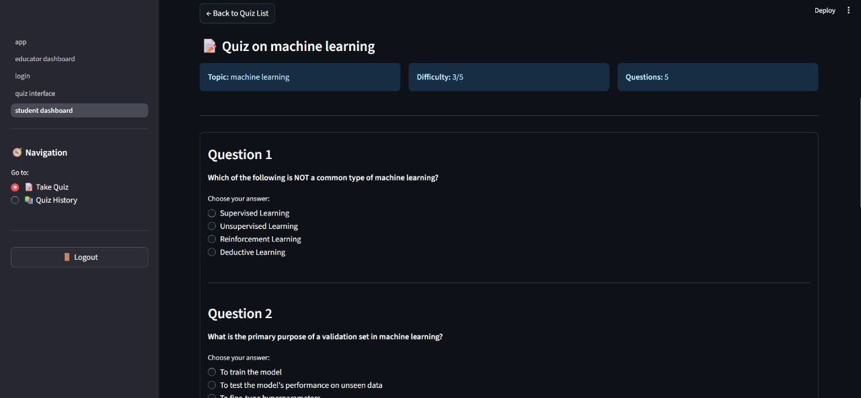

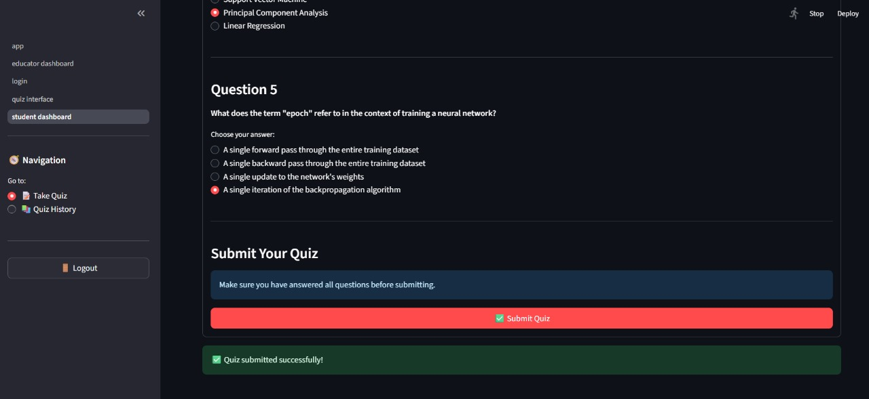

Detailed explanatory feedback on quizzes: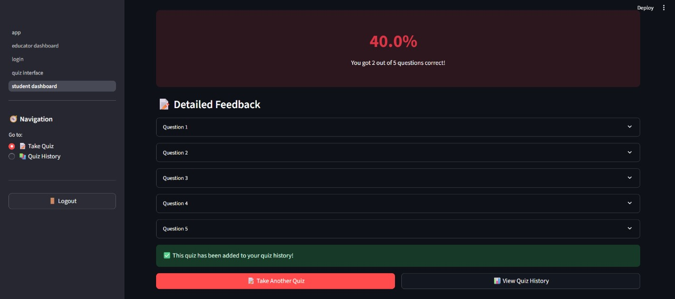

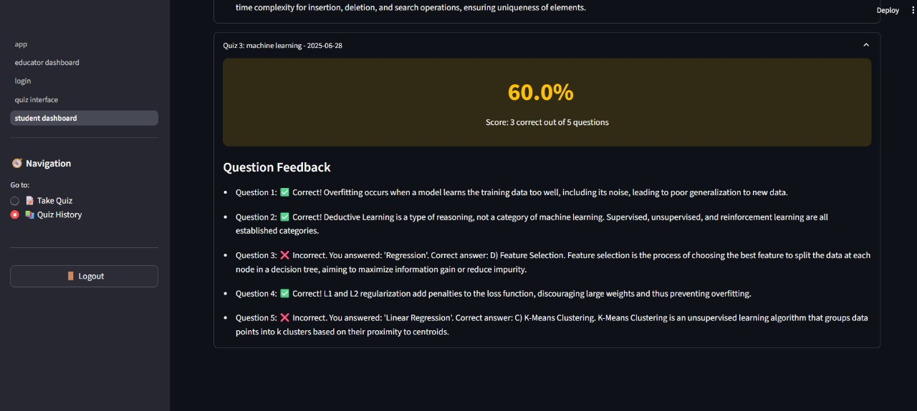

Quiz history:

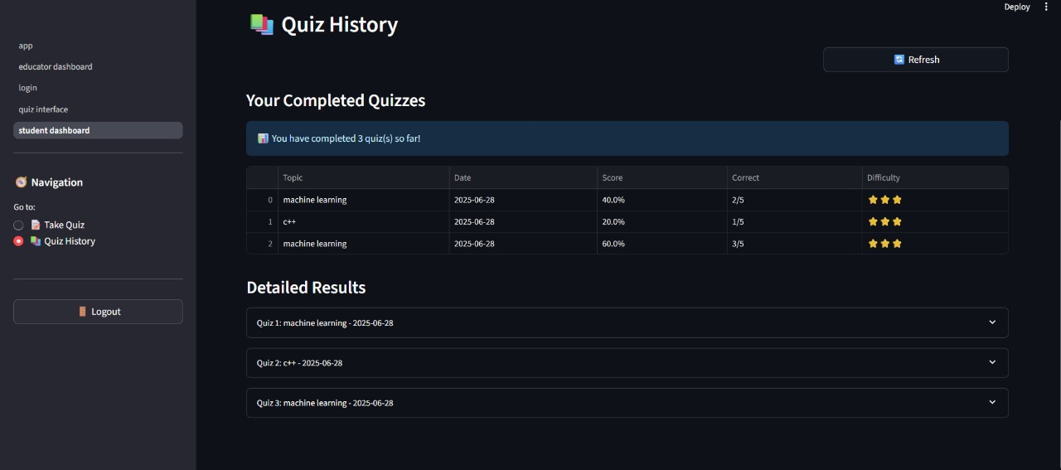

**8. ADVANTAGES & DISADVANTAGES**

The development and deployment of EduTutor AI introduced a number of innovative features and efficiencies, especially in the areas of personalized learning, real-time assessment, and LMS integration. However, like any complex system, it also presented certain limitations that must be acknowledged for future enhancement and broader deployment. This section outlines the key advantages and disadvantages observed during the project lifecycle and testing phases.

### ****Advantages****

One of the most significant advantages of EduTutor AI is its ability to deliver **personalized learning experiences**. Traditional learning platforms often present content uniformly to all students, disregarding individual learning pace, prior knowledge, and specific weaknesses. EduTutor AI addresses this by using AI-powered diagnostics and adaptive quiz generation to tailor the learning path to each student. This fosters engagement, improves concept retention, and supports differentiated instruction at scale.

The platform’s use of **real-time feedback**—powered by IBM Watsonx—further enhances its educational value. Students do not need to wait for manual grading or generic remarks. Instead, they receive contextual explanations, suggested resources, and targeted insights immediately after submitting their responses. This not only accelerates learning but also builds student confidence by clarifying mistakes in a constructive manner.

Another strong advantage lies in EduTutor AI’s **seamless integration with Google Classroom**. Educators and institutions already using Google Workspace can onboard with minimal effort. By importing rosters, course structures, and assignments directly from the Google Classroom API, the platform ensures curriculum alignment while eliminating repetitive data entry. This ease of adoption increases its potential for real-world classroom deployment.

The **educator dashboard** is also a highlight, offering a rich visual interface to monitor student progress, quiz performance, and learning trends. Teachers can identify at-risk students, compare progress across topics, and assign AI-generated quizzes directly, streamlining the intervention process and improving teaching effectiveness.

### ****Disadvantages****

Despite its strengths, EduTutor AI also presents a few limitations, particularly around **dependency on AI models**. While models like Watsonx and Granite enable personalization, their response times can vary depending on the load and internet conditions. In high-concurrency environments, quiz generation latency may affect the user experience unless mitigated by caching or preloading mechanisms.

Another challenge is the **initial complexity of setup**, particularly when configuring Google APIs and integrating OAuth workflows. While this was streamlined for the MVP, deploying at scale across institutions may require administrative coordination, technical support, and training for educators unfamiliar with AI-driven platforms.

There is also the risk of **technology overdependence**, especially in environments where students have limited digital access or face connectivity issues. Since the system requires cloud access and real-time model calls, offline use is currently not supported—a potential limitation in rural or bandwidth-constrained settings.

Lastly, the AI's accuracy in interpreting subjective or long-form answers, while impressive, is not infallible. Continuous model tuning and human-in-the-loop feedback will be important for high-stakes assessments or sensitive academic environments.

EduTutor AI introduces transformative educational advantages through AI personalization, instant feedback, and LMS integration. While some technical and adoption challenges exist, the overall system demonstrates strong potential for improving academic engagement and efficiency. With further optimization, it can become a reliable tool in both traditional and tech-forward classrooms.

## **9. Conclusion**

EduTutor AI represents a forward-thinking leap in the evolution of educational technology. At a time when classrooms and institutions are grappling with the need to provide more inclusive, adaptive, and effective learning environments, EduTutor AI offers a solution that is both intelligent and practical. By combining the power of generative AI with real-time feedback and seamless integration into existing classroom workflows, the platform bridges the gap between personalized learning and scalable implementation.

At the heart of the platform’s success is its ability to individualize the learning experience for every student. Leveraging the capabilities of IBM Watsonx and Granite LLMs, EduTutor AI is not simply a content delivery system, but an adaptive engine that learns from student interactions and continuously adjusts content to their level. This real-time personalization ensures that students are consistently challenged at the right level, motivated by progress, and supported with targeted feedback. It transforms assessment from a judgmental act into a constructive process, guiding learners rather than simply measuring them.

For educators, the platform reduces the manual overhead of content generation, grading, and performance tracking. The real-time dashboard, backed by Pinecone’s vector analytics, allows instructors to quickly identify struggling students, monitor class-wide trends, and intervene with precision. The educator's role shifts from content manager to strategic mentor—focusing on guidance and support rather than administrative overhead.

A major factor in EduTutor AI’s success is its seamless **integration with Google Classroom**. By automatically syncing course content and rosters, the platform fits effortlessly into the systems that many schools already use. This not only streamlines deployment but also enhances user trust and institutional compatibility.

Throughout the development process, the platform demonstrated strong technical viability. Functional and performance testing confirmed its stability under concurrent usage, responsiveness of AI model integration, and robustness of user flows. Despite minor challenges such as AI latency and integration complexity, these were effectively managed through planning, fallback mechanisms, and system design resilience.

EduTutor AI also demonstrates a modular and extensible architecture, positioning it well for future upgrades. Its microservice-friendly structure enables easy incorporation of additional features like multi-language support, curriculum customization for different educational boards, and gamified learning mechanics. With the core foundation already stable and scalable, EduTutor AI is ready for broader institutional use or academic trials.

In conclusion, EduTutor AI successfully validates the idea that AI can be leveraged not just to digitize education, but to **personalize and humanize it**. By making learning adaptive, feedback immediate, and teaching more insightful, the platform stands as a testament to how thoughtful AI integration can transform education into a more effective and inclusive experience. It lays a strong foundation for future educational innovation and reaffirms that the classroom of tomorrow must be both data-driven and learner-centered.

## **10. Future Scope**

While EduTutor AI has successfully demonstrated its ability to deliver personalized learning experiences through AI-driven quiz generation, feedback, and educator analytics, its current version represents only the beginning of what the platform can become. The project’s modular architecture and extensible design allow for a wide range of future enhancements, expansions, and integrations that can elevate it from a classroom-level tool to a comprehensive, institution-wide learning solution.

One of the most promising areas of growth is the **expansion of subject coverage and academic levels**. While the current MVP focuses on core academic topics, future iterations can include support for higher education subjects, vocational training, and even competitive exam preparation. By incorporating specialized knowledge bases and model fine-tuning, the platform can deliver tailored experiences to students across disciplines—from humanities to engineering and business studies.

Another key enhancement will be the integration of **multilingual support**. In diverse educational settings where students speak different native languages, enabling content delivery, quizzes, and feedback in regional or global languages (e.g., Hindi, Spanish, Arabic, etc.) will ensure broader accessibility and inclusivity. With AI models increasingly capable of multi-language processing, EduTutor AI is well-positioned to become a truly global platform.

In terms of learning experience, introducing **interactive learning formats** such as flashcards, video-based explanations, simulations, or AI-generated summaries can increase engagement and cater to multiple learning styles. These formats can complement traditional quizzes and provide deeper conceptual understanding, particularly in visual or practical subjects. Integration with educational tools like Khan Academy, Coursera, or open-source video content could further enrich the learning journey.

The educator experience can also be improved with **predictive analytics** powered by machine learning. Rather than simply reporting historical performance, the system could begin forecasting potential dropouts, performance dips, or skill gaps. These proactive insights could help teachers intervene even before a student falls behind, transforming teaching from reactive to preventive.

From a technical and operational standpoint, the platform can evolve to support **offline learning modes**, enabling quiz access and feedback even in low-bandwidth or disconnected environments. This could be achieved through local caching, progressive web app (PWA) deployment, or mobile-first versions, making EduTutor AI viable in remote or underserved regions.

Another significant area for expansion is **integration with other Learning Management Systems (LMS)** beyond Google Classroom. Platforms like Moodle, Canvas, Blackboard, or Microsoft Teams could be supported through API plugins, making EduTutor AI compatible across a wider educational ecosystem. This would be particularly valuable in higher education and enterprise training environments.

Finally, as AI ethics and responsible AI governance gain prominence, EduTutor AI could incorporate features like **explainable AI (XAI)**, bias detection, and audit logs to ensure transparency and fairness in student evaluation—especially for high-stakes assessments.

**11. APPENDIX**

GitHub & Project Demo Link: [prabhashaj/EdututorAI](https://github.com/prabhashaj/EdututorAI)